
PHYSICS 1421 SECTION:

NAME: ID#:

Experimental Uncertainty and Error Analysis

Introduction: In the physical sciences as well as in engineering, we depend on accurate measurements of real-world objects to test our theories and to design the things we build. In this lab we will study the accuracy of measurements and how this accuracy affects things we calculate from measured values.
All measurements are subject to "experimental uncertainty", sometimes called "experimental error". These terms do not refer to any kind of "mistake" or “blunder”¹ in making measurements. It is simply an observed fact that when repeated, independent measurements are made on a physical system, the measured values will not generally all be exactly the same. (We will see this happen in this lab.) To make progress in experimental science and engineering, it is important to strive to reduce these measurement errors, and to be able to calculate the effect they will have when we use measured values to calculate desired quantities and results. In this lab the whole class will work as a large group, each person measuring the diameter and the mass of a metal object. We will study the spreads of the measured values and relate them to characteristics of the measurement tools. We will calculate the volume and density of the object from our measurements.
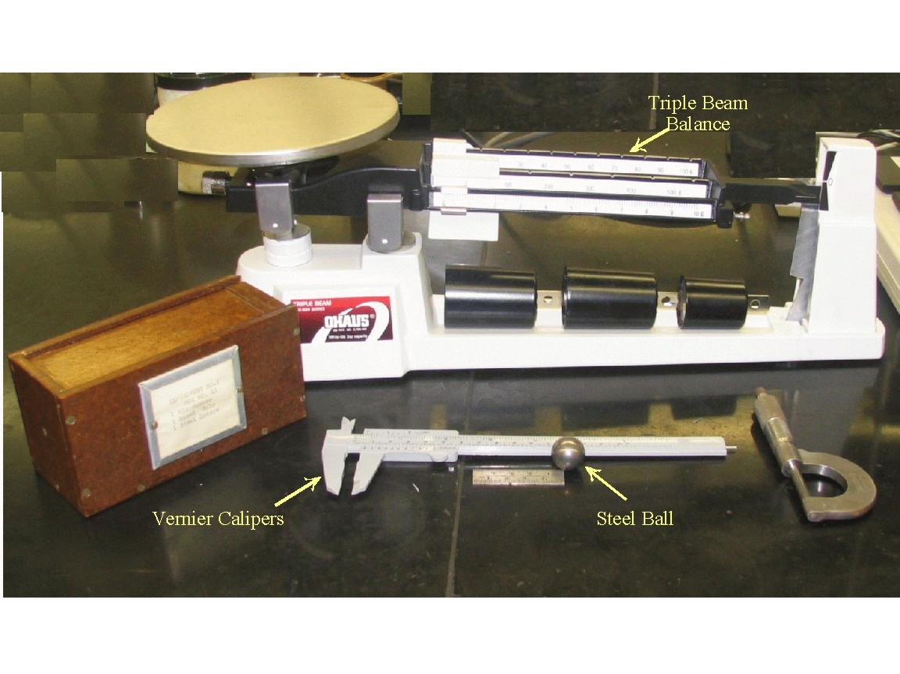

Figure 1. Steel ball, triple beam balance, a ruler and a Vernier Caliper. Metal calipers are sharp. Use with CUATION. Vernier Micrometers are also shown and often used to make precise measurements.
Equipment:

- Vernier Caliper.
- Triple-beam balance.
- Steel ball (one for each group).

Procedure: In this part of this lab we will study the measurement process itself. That is, the fact that each and every measurement ever made has some uncertainty. There is no such thing as a “Perfect Measurement”. You can see one aspect of this inability to make a perfect measurement quite easily. What if a measurement comes out between the finest markings on your measurement scale? What value would you assign to this measurement? There is no way to be certain of this value.
We will do five different measurements of the diameter and the mass of a metal ball. You will make groups of five. Each one will do a measurement of diameter and mass of the ball.
We will find the standard deviation according to the formula,

- The instructor will discuss the formula in details.

Do the following:

Measure the diameter of the steel ball using the Vernier calipers (see Appendex A).
Measure the mass of the steel ball using the triple-beam balance.
Fill in the table below using the measurements of your group.

Trial | Diameter (cm) | Mass (g) | Volume(cm³) [V=4πR³/3] | Density(g/cm³) [ρ=m/v]
1.
2.
3.
4.
5.
Mean
Standard Deviation

Analysis:

Calculate the mean (average) and the standard deviation for the diameter and the mass measurements. Some calculators have these functions built-in.
Enter the mean and standard deviation into the table in the indicated cells. Typically one takes an average value to be their best measurement and the standard deviation to be a measure of the spread in their measurements.

Let us try to understand the meaning of the standard deviation in terms of the measurement process itself. How precise would you expect the length measurements to be? What about the mass measurements? Consider the following:

a. What is the smallest division you can read on the Vernier scale of the calipers?
b. How much must you move the smallest sliding weight on the triple-beam balance to noticeably change the balance condition?
c. Compare the standard deviations of the measured data sets with the expected precisions from the preceding question. Are they similar? (They should be.)

From the preceding exercises we should hopefully learn that: Repeated, independent measurements of a quantity will vary about the average measured value. The majority of measurements lie within one standard deviation of the mean. Thus we can be reasonably confident that if we had measured the quantity only once, that value would differ from the mean of many repeated measurements by at most a standard deviation or so. The standard deviation found on repeated measurements will be similar to the precision of the measuring equipment (at best). Thus if we know only one measured value and something about the equipment, we can have an idea of the likely difference between our measured value and the mean of a large number of repeated measurements. One or two measured values which lie far from the mean ("outliers") can strongly influence the calculated standard deviation. There are many reasons why outliers can occur. Occasionally they may represent "mistakes" in the measurement procedure, rather than chance fluctuations, but one must be very careful not to assume this. There are statistical tests which we will not discuss, that can show whether it is mathematically reasonable to discard such outliers. In some cases outliers show new and interesting phenomena and scientist mine data looking for such occurrences.
Uncertainty in Derived Quantities; Error Propagation: Typically the value of the physical parameter of interest is not obtainable from one measurement. In nearly all cases one must combine a number of measurements to arrive at the final desired result. What we are interested in studying in this part of our experiment is how experimental uncertainties in our measured values propagate through our calculations and affect the certainty of our final result. Not taking this propagation of error volumes into account correctly can have disastrous results. We will study this effect by analyzing how the uncertainty in our measured values of diameter and mass effect calculations of the balls volume and density. Along the way we will learn some rules for error propagation.
o Calculate the volume of the ball from each diameter measurement using the proper formula, and enter the values in your table.
o Calculate the mean and standard deviation of the volume data set and enter them into your table.
O Calculate the density of the ball from each volume value and mass measurement using the
proper formula and enter the values into your table.
o Calculate the mean and standard deviation of the density data set and also enter them into your table.

For example, if you were the engineer whose job it was to design a rail system and you didn’t take uncertainties properly into account, look what could happen.
From this section we have hopefully learned that in order to get the best estimate of a derived quantity, such as density, one can take multiple independent measurements of the input quantities (i.e. mass, diameter), and then calculate the derived quantity using the various combinations of the input quantities. The mean of the derived quantity would then represent our best estimate, while the standard deviation would represent the uncertainty in our derived quantity. Hopefully though, while we see this is a useful exercise to build understanding and intuition, it would be a terrible practice. We should instead make a best measurement of our input quantities, using the smallest division on our measuring apparatus as a measure of our uncertainty. Then using our best measurements of our input parameters calculate a best estimate of our derived quantity. The uncertainty in our derived quantity can be obtained using our rules for error propagation.
Note: when we do only one measurement and not repeated measurements, we typically use “± ½ the smallest division” of our measuring apparatus as the uncertainty in our measurement (standard deviation).

Appendex A

How to use the vernier caliper: If you are unfamiliar with the use of the vernier caliper, A diagram is presented below.
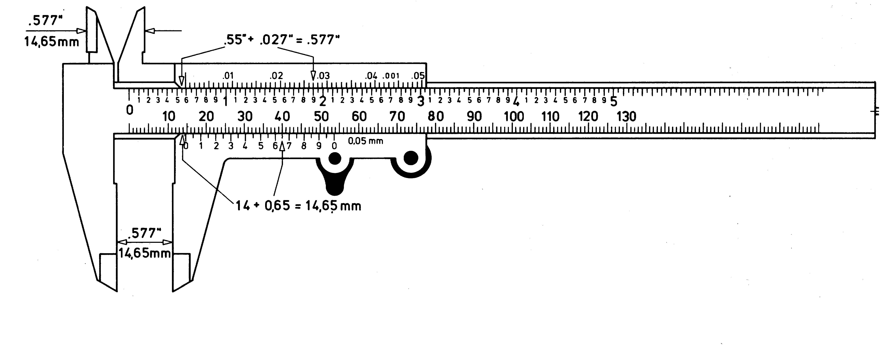

There are two scales on the vernier caliper instrument, the top two scales use inches, and the bottom two scales use millimeters. Let’s see how we read a measurement of length of 14.65.
Note: The scale that runs from 0 to 130 (your caliper might run to 120), we are going to call this scale the top scale. Each of those divisions is 1 mm. Note the smaller scale right below, the one that starts with 0 and ends with 0, with 0.05 mm written beside it, each division on this scale is 0.05mm.
Line up the first 0 on the smaller scale with the number above it on the larger scale. This 0 falls between 14 and 15 mm on the larger scale. That means that the jaws are open between 14 and 15 mm. This gives us the whole mm part of the measurement. Now look on the smaller scale, and see where the line, or tick mark, of the smaller scale, lines up best with a line on the upper scale. The line between 6 and 7 lines up very well with line for 40 on the upper scale, this is .65mm, the fractional part of the measurement.
To get the final answer, we add the two numbers, 14 and .65, for 14.65mm. Note that since the fractional scale is divided up in 0.05mm steps, the last digit in our measurements will be a 0 or 5. The calipers need some practice, so give yourself the time you need.

LAB QUESTIONS AND ANSWERS SECTION:
1. How precise would you expect the length measurements to be based on the instrument?

2. How precise would you expect the mass measurements to be based on the instrument?

3. Consider the following:
a. What is the smallest division you can read on the Vernier scale of the calipers?

b. How much must you move the smallest sliding weight on the triple-beam balance to noticeably change the balance condition?

c. Compare the standard deviations of the measured data sets with the expected precisions from the preceding question. Are they similar? (They should be.)

4. What did you learn from this lab exercise? (Be as detailed as you like).

